**UPS Shipments**

1. Pull all the requested items on the pick ticket, let the Order Taker know of any shortages.
2. Read and follow all of the notes on pick ticket regarding shipping and pulling order. Some orders may need to be shipped “blind”, in this case we cannot let the receiver know where the package shipped from – cut our name out from the return area on the shipping label and do not send a packing list (unless a modified one is provided)
3. Double check all items and quantities match the pick ticket.
4. Package the order into an **adequately** sized box, keep in mind the abuse packages take.
   1. Heavy items must be packed in thicker, sturdier boxes, using loose packaging as reinforcement
   2. Smaller & fragile items must be packed in way to prevent other items in the box from crushing or damaging them
   3. Nothing should shift inside when shaking the box! Add more packing to keep items secure
   4. Make sure any old stickers/labels/barcodes are removed or covered with a new label
   5. Do not use boxes from our competitors
5. Label order number on the outside of the package, this will help insure you are sending the correct package in case you are pulled away for another task mid-shipment.
6. Write the length, width, height, and weight - rounded up to the nearest whole number - on one of the pick tickets. Discard the other copy
7. Take the pick ticket to the shipping computer, open the “Shipping” (Order Processing->Transaction) module. Enter the pick ticket number and hit enter
8. Verify you have the correct pick ticket entered and look for changes to the quantities and adjust accordingly
9. Navigate to the “UPS OnLine” tab (fig.1), right click and choose “View/Edit Shipment Details”. This is where the majority of the package information will be entered. *if an order is selected for “UPS Red/Blue” you may have to change the carrier to UPS Collect for the tab to be visible*

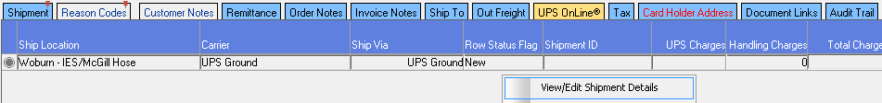

**\*\*\*\*ADDITONAL STEP FOR UPS COLLECT AND NON-GROUND PACKAGES (NDA, 2ND DAY, RED, BLUE ETC)\*\*\***

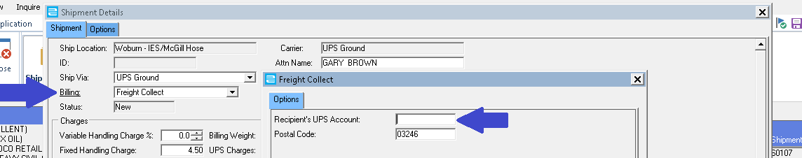 If an order has UPS COLLECT for a carrier **OR** a UPS account number is in the order notes, please change the billing option from the default “Prepaid”, to “Freight Collect”. This will open a new window requesting the UPS account number, if the account number is saved into P21 it will be filled in already. If no account number has been saved you must enter it in this window. See fig.2

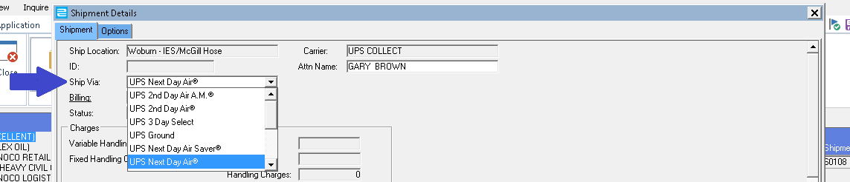To ship an order with an upgraded method - i.e. Next Day Air, 2ND Day Air, or another option other than standard Ground - use the Ship Via drop down menu to choose the requested method.

**\*\*\*\*\*\*\*\*\*\* END ADDITONAL STEPS, FOLLOW ALL DIRECTIONS BELOW \*\*\*\*\*\*\*\*\*\***

1. 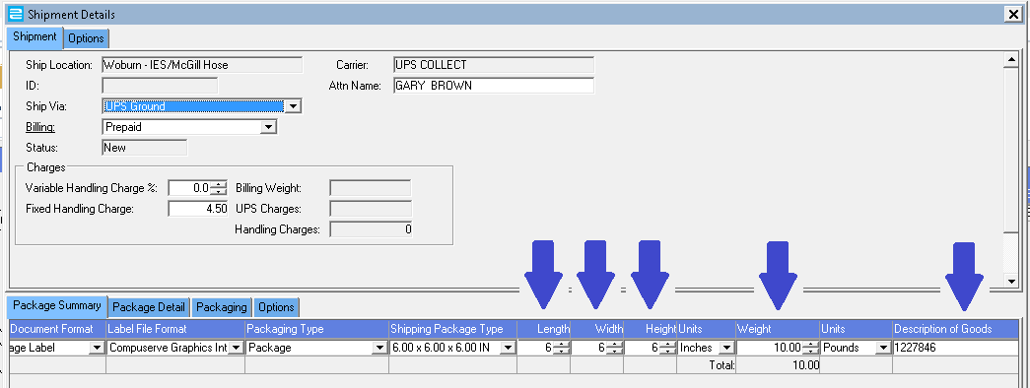Enter the package’s length, width, height, and weight into the first row of the “Shipment Details” screen. Enter the Order Number in the “Description of Goods” column. You must hit enter or tab after each box for the information you entered to update in P21.
2. 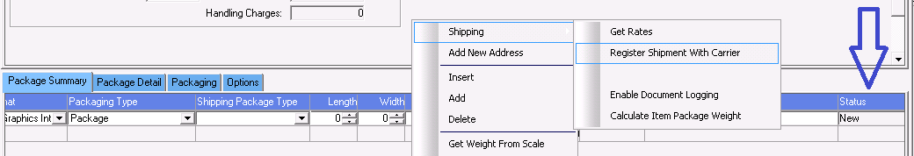Confirm the information you entered is accurate and then register the shipment with UPS. To register, right-click and choose Shipping->Register Shipment With Carrier. You should see the column labeled “Status” *all the way to the right* change from “New” to “Accepted”.
3. Once the package has been accepted by UPS, you can click the close button on the lower right side of the Shipment window and P21 will ask you where to print the shipping label. Choose the Woburn Shipping printer and print one copy.
4. With the shipping label printed we still need to print 2 Packing Lists and confirm the shipment with P21. Navigate back to the “Shipping" tab, confirm the check box to Print is selected is under the Pick Ticket area. Invoices will need to be printed only when it is a Front Counter Sale.
5. Before saving, double check shipping and billing methods are correct and you are following any notes/requirements for the order, such as shipping blind. Verify the shipping box does not have any old shipping labels/stickers/barcodes – remove or cover any old labels
6. Click the save button, P21 will ask you where to print the Packing Lists, print 2 copies to your Woburn Shipping printer. Staple one copy to the original pick ticket, place on the file cabinet to file away a different time. The other copy can be attached to the box, inside of a packing list sticker. Attach the UPS label and place by the dock door for pickup